SLaM Network Survey 2014 Overview

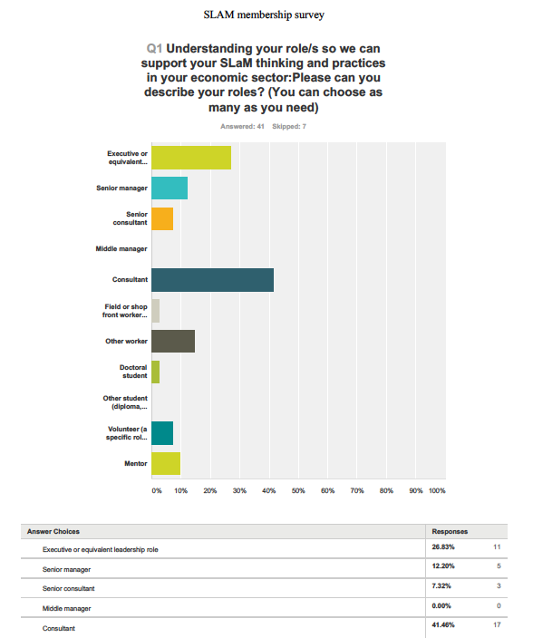
At the end of 2014, the Committee members agreed to each call 10-15 people on our network lists, to ask them some questions that we had put together in a survey.

Some of us used the survey, and others had a more informal conversation that added to some of the survey questions. We attempted to speak to some 200 people, and ended up with 48 responses in the survey – though we spoke to some 70 people.

Most (67%) of those we spoke with are either consultants or at executive levels of leadership in their organisations. Most (71%) work in small businesses or are self-employed. Education was the most dominant industry sector (54%), with health, human and organisational development and spirituality-focussed organisations also significant (20-30%). We are mindful that these figures only represent those we spoke with and are not necessarily a complete picture of our network members.

People already have strong capabilities in leadership and visioning, self-development, communication, collaboration and being independent thought leaders. What people want from SLaM is to learn about:
- The ways in which spirituality can be understood in leadership and management contexts (80%)
- How to practice forms of spirituality in work and everyday life (75%)
- And about different kinds of spirituality and their value to health and wellbeing (45%)
Learning about indigenous spirituality, religions, the value, the future and risks associated with spirituality in the workplace were of least interest (2-6%).

By far, respondents’ most pressing problem was experiencing a lack of opportunity to realise potential (75%). Co-worker relationship problems, exhaustion and depression were the next level of concern. Financial pressures and bullying were of least concern (under 20%).

Books, being in sacred spaces and participation in events –both face to face and on line - were most valued ways that our network members developed their interests in our area. By far (70%) of interviewed members want from SLaM the kinds of activities that let them feel a sense of being part of a community that affirms their understandings about spirituality in organisations. Talking up front, or opportunities to rest, were of least interest.

83% of respondents were between 51 and 70 years of age, with slightly more females to males – but the unequal data entry resulting from different approaches to using the survey means that these demographic results are not very strong.
Both distance from events and restrictions on time were the most inhibiting factors with regard to engaging with us.

